16 BIT SUBTRACTION

AIM: To write an assembly language program 16 bit addition using 8086 processor.

ALGORITHM:

1. Start the program.
2. Load SI with memory location.
3. Move data of SI to AX.
4. Add AX with BX.
5. Increment SI.
6. Move data from AX to SI.
7. Stop.

PROGRAM:

MOV AL, 06H

MOV BL, 0AH

SUB BL, AL

MOV CX,00008H

PRINT: MOV AH,02H

MOV DL,030H

TEST BL,080H

JZ ZERO

MOV DL,031H

ZERO: INT 021H

SHL BL,1

LOOP PRINT

MOV DL,062H

INT 021H

MOV AH,00H

INT 016H

RET

NOP

NOP

NOP

RET

INPUT:

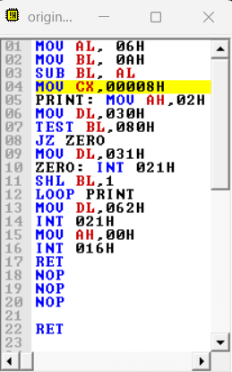

OUTPUT:

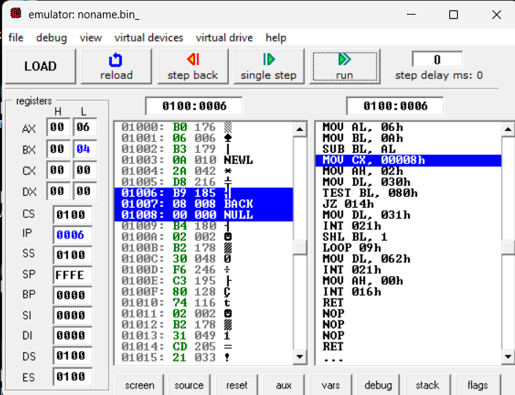

RESULT:

Thus the program was executed successfully using 8086 processor.